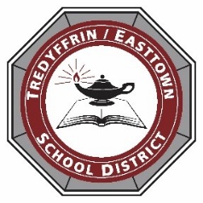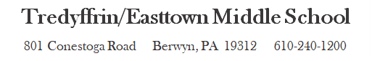

Dear TEMS Guardians,

TEMS Picture Day will be held over several days this year to accommodate our hybrid and virtual students. The dates for our hybrid students are Monday, November 16th for the A - K alpha band and Friday, November 20th for our L - Z alpha band. Virtual students will have the opportunity to take pictures on Wednesday, November 18th from 1:00pm – 6:00pm. All pictures will be taken in the auditorium and auditorium lobby area.
These pictures will be used for our yearbook, so we ask that all students have their picture taken if you are comfortable with it (even if you are not purchasing pictures). If you prefer to send us a picture of your child with a plain color background, we will accept those later in the year. Picture make-ups are available on Monday, January 11th for A - K alpha band and Thursday, January 14th for L - Z alpha band.
Picture order forms will be coming to you in the mail for mail-in orders or you can order pictures online at https://www.barksdalephoto.com/onlineorders.php#orderbox (online order code 01033).
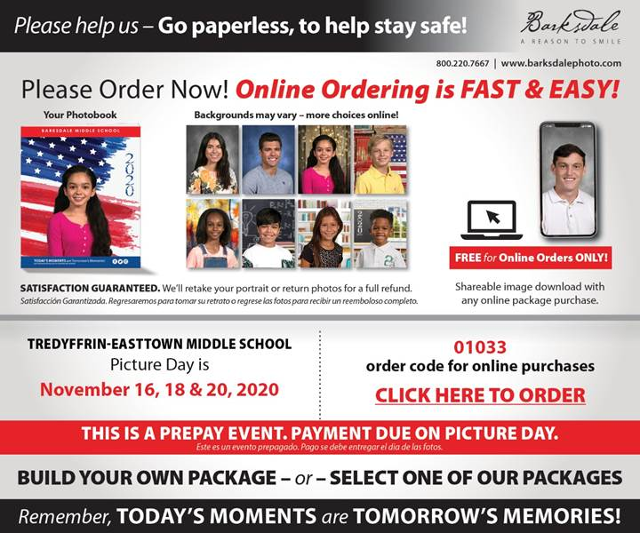
All orders are due on your child’s picture day: November 16^{th,} 18th or 20^{th.} On picture day, students will need to show a print-out of the receipt from online ordering or hand-in a picture form. If you have any questions, please contact Mrs. Kim D. Morris, Assistant Principal, at 610.240.1229.

Thank you!

Kim D. Morris
Assistant Principal
Tredyffrin/ Easttown Middle School

